Class 2 – Global Energy Transition

Instructor: Nate Tucker

Date: 30-Jan-2021

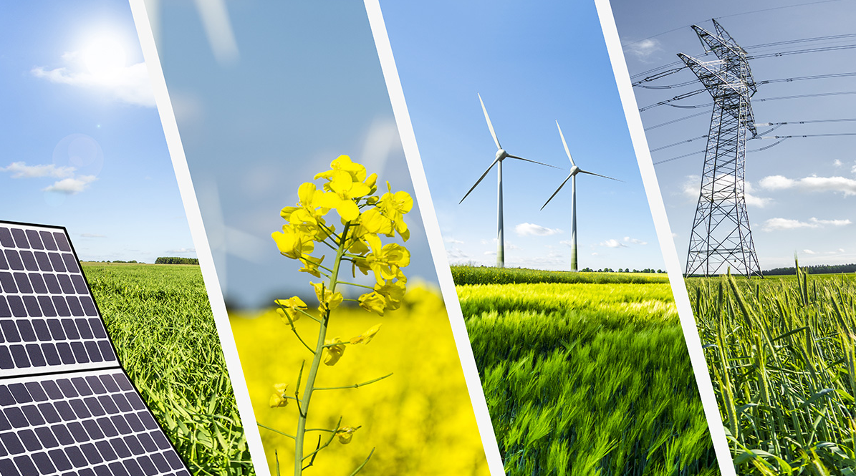

# About Us:

* Nate Tucker – Instructor
  + One fun thing you did over the last week:
  + One large use of energy in the last week:
* Ramsay Birkhahn
  + One fun thing you did over the last week:
  + One large use of energy in the last week:
* Caroline Keohane
  + One fun thing you did over the last week:
  + One large use of energy in the last week:
* Alexa Nares
  + One fun thing you did over the last week:
  + One large use of energy in the last week:
* Erika Nares
  + One fun thing you did over the last week:
  + One large use of energy in the last week:
* Karla Medrano
  + One fun thing you did over the last week:
  + One large use of energy in the last week:
* Carlos Valencia
  + One fun thing you did over the last week:
  + One large use of energy in the last week:
* Diego Ramirez
  + One fun thing you did over the last week:
  + One large use of energy in the last week:
* Catalina Gallardo
  + One fun thing you did over the last week:
  + One large use of energy in the last week:
* Rowen Manriquez
  + One fun thing you did over the last week:
  + One large use of energy in the last week:
* Abigail Marin Iniestra
  + One fun thing you did over the last week:
  + One large use of energy in the last week:

# Course Overview:

* 5 Saturday Meetings - Discussion oriented
  + Intro to Energy
  + Conventional Energy Sources (coal, natural gas, petroleum)
  + Renewable Energy Sources (wind, solar, tidal, geothermal, hydro, etc.)
  + Upcoming Technologies, Future Goals, Industry Shifts
  + Sustainability in our lives

# Feedback from Class 1

* What we learned
  + Many types of energy
  + Our society is inefficient, we waste a lot of energy
  + “Sustainable” technologies depend on their energy source
  + Articles about energy can be biased
* Goals for today
  + Quicker
  + More interaction

# Investigation – Coal

a. Energy source name. Coal

b. Is it renewable or non-renewable?

c. If non-renewable, how many years of world/U.S. reserves are left?

d. Is it used for electricity generation, heating, and/or transportation fuel?

e. What percent of California’s electricity or heating does the source supply? What percent of the U.S.’s transportation fuel does the source supply?

f. How is the source converted into usable energy?

g. Can the energy source produce energy upon demand (instantly)?

h. Is the energy from the source commonly used where it is generated?

i. Use resource maps or other data to comment on the abundance of the source in California and in your region of California.

j. How does the cost of using the energy source compare to alternatives?

k. What are the environmental costs and benefits of the energy source, including impacts on wildlife habitat, ecosystems, and the atmosphere?

l. Do you believe the source is overutilized, underutilized, or utilized at the right level in California? Why?

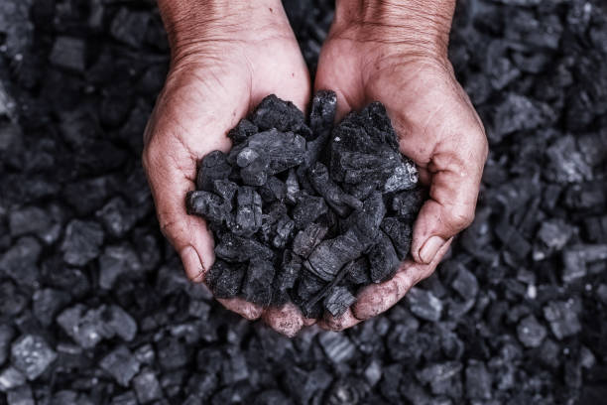

Coal

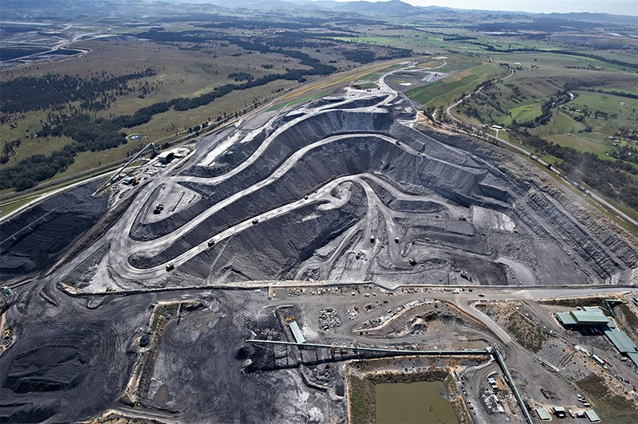

Australian Coal Mine from above

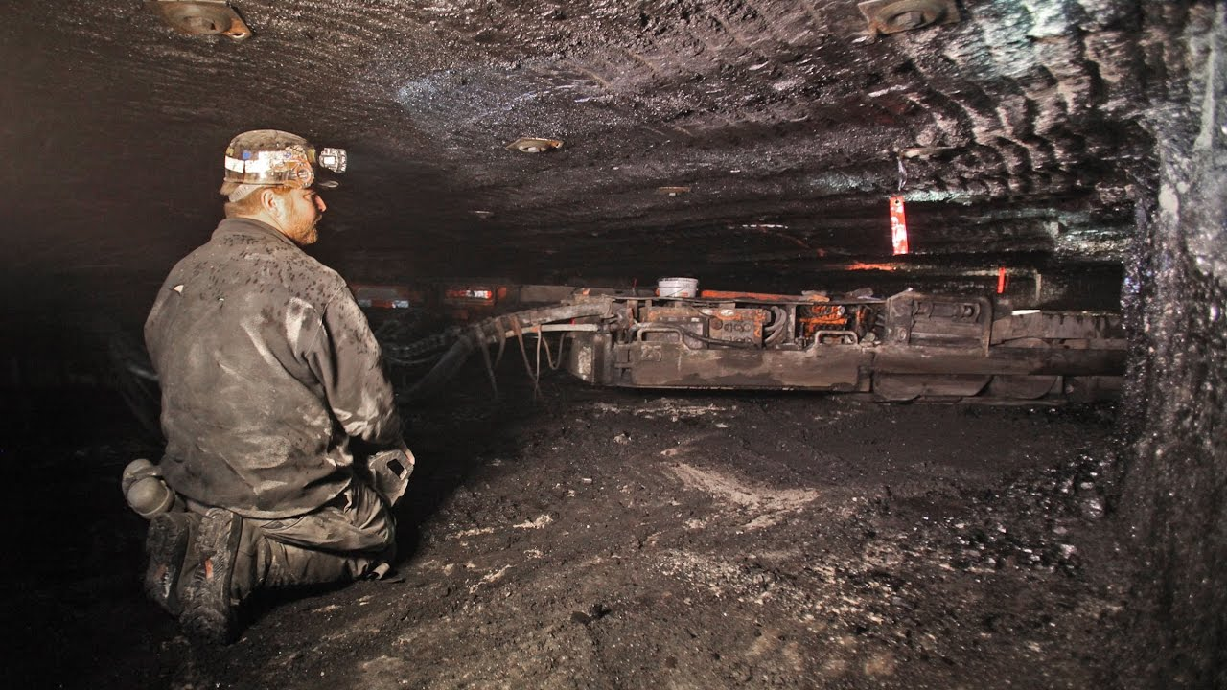

Inside an Ohio Coal Mine

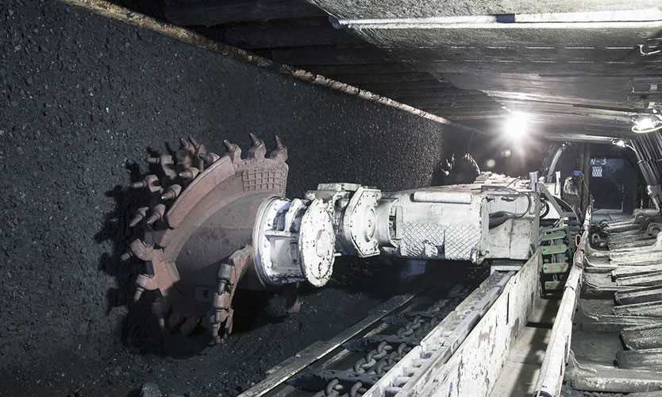

Machinery in a coal mine in Poland

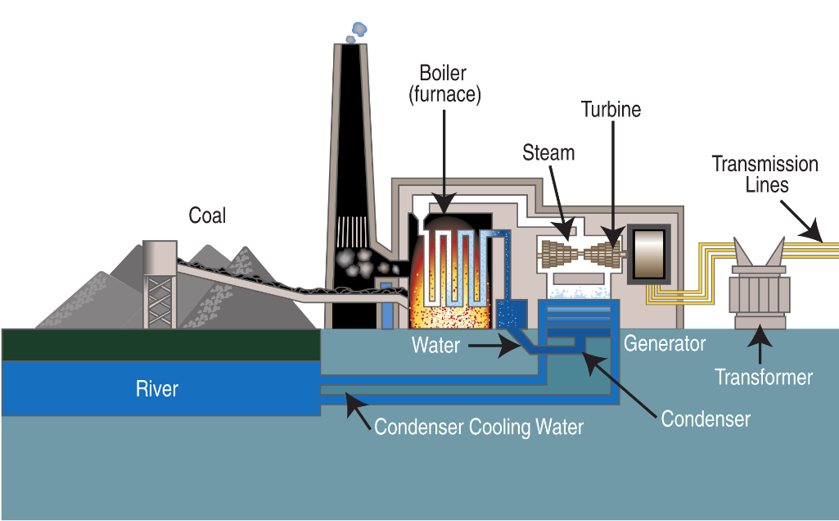

Typical steam-cycle coal power plant

# Investigation – Natural Gas

a. Energy source name. Natural Gas

b. Is it renewable or non-renewable?

c. If non-renewable, how many years of world/U.S. reserves are left?

d. Is it used for electricity generation, heating, and/or transportation fuel?

e. What percent of California’s electricity or heating does the source supply? What percent of the U.S.’s transportation fuel does the source supply?

f. How is the source converted into usable energy?

g. Can the energy source produce energy upon demand (instantly)?

h. Is the energy from the source commonly used where it is generated?

i. Use resource maps or other data to comment on the abundance of the source in California and in your region of California.

j. How does the cost of using the energy source compare to alternatives?

k. What are the environmental costs and benefits of the energy source, including impacts on wildlife habitat, ecosystems, and the atmosphere?

l. Do you believe the source is overutilized, underutilized, or utilized at the right level in California? Why?

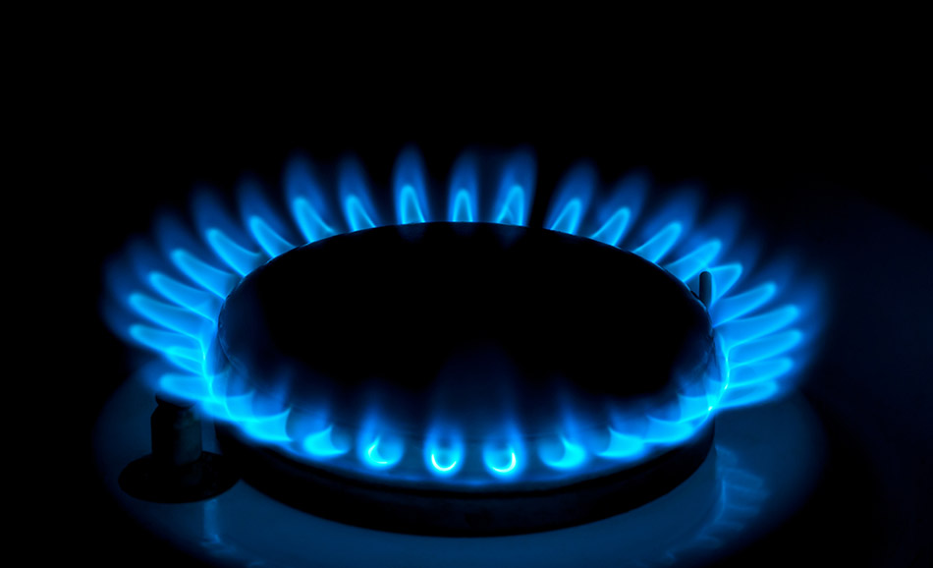

Does your stove look like this?

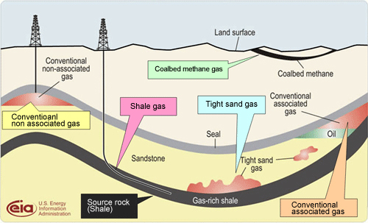

Natural Gas sources

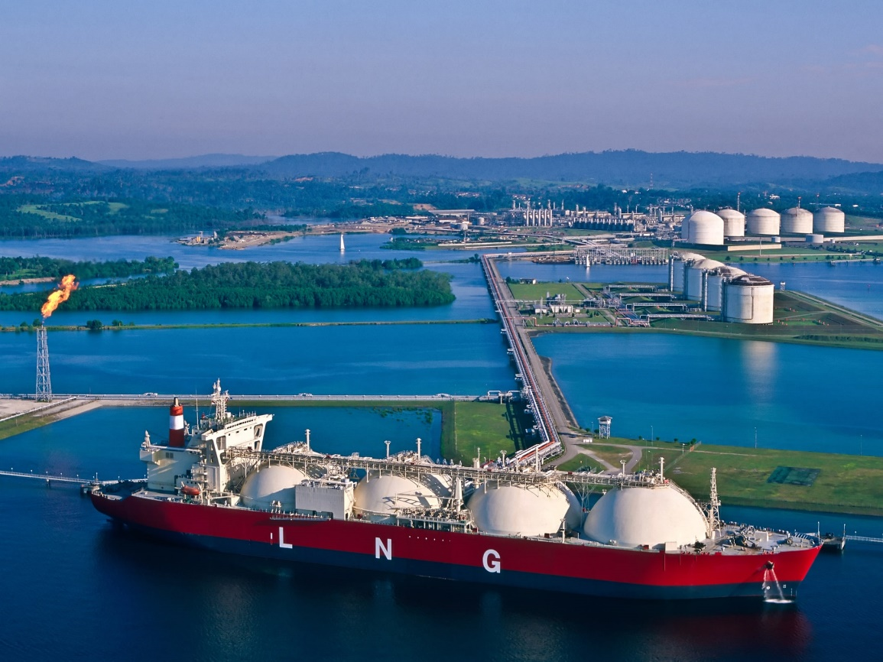

Natural gas transport (tanks and pipelines)

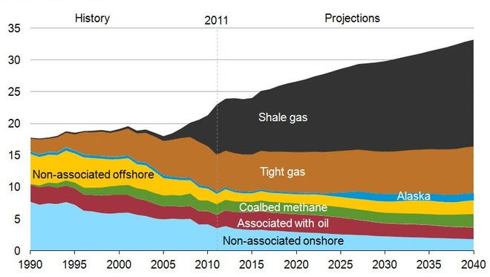

Breakdown of available Natural gas in the U.S.

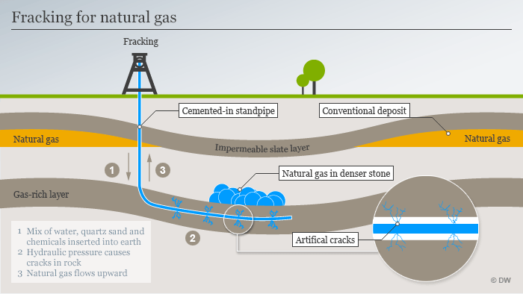

Fracking

# Investigation – Petroleum/Oil

a. Energy source name. Petroleum/Oil

b. Is it renewable or non-renewable?

c. If non-renewable, how many years of world/U.S. reserves are left?

d. Is it used for electricity generation, heating, and/or transportation fuel?

e. What percent of California’s electricity or heating does the source supply? What percent of the U.S.’s transportation fuel does the source supply?

f. How is the source converted into usable energy?

g. Can the energy source produce energy upon demand (instantly)?

h. Is the energy from the source commonly used where it is generated?

i. Use resource maps or other data to comment on the abundance of the source in California and in your region of California.

j. How does the cost of using the energy source compare to alternatives?

k. What are the environmental costs and benefits of the energy source, including impacts on wildlife habitat, ecosystems, and the atmosphere?

l. Do you believe the source is overutilized, underutilized, or utilized at the right level in California? Why?

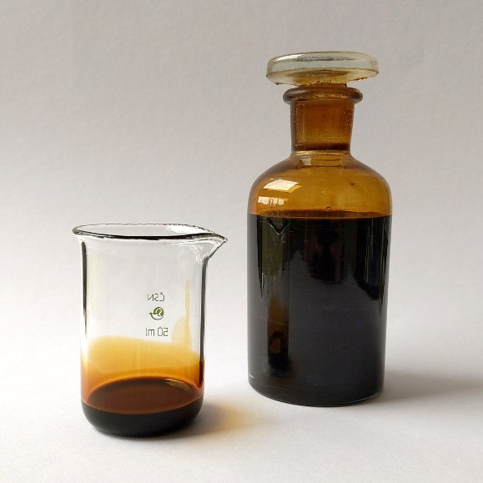

Sample of petroleum

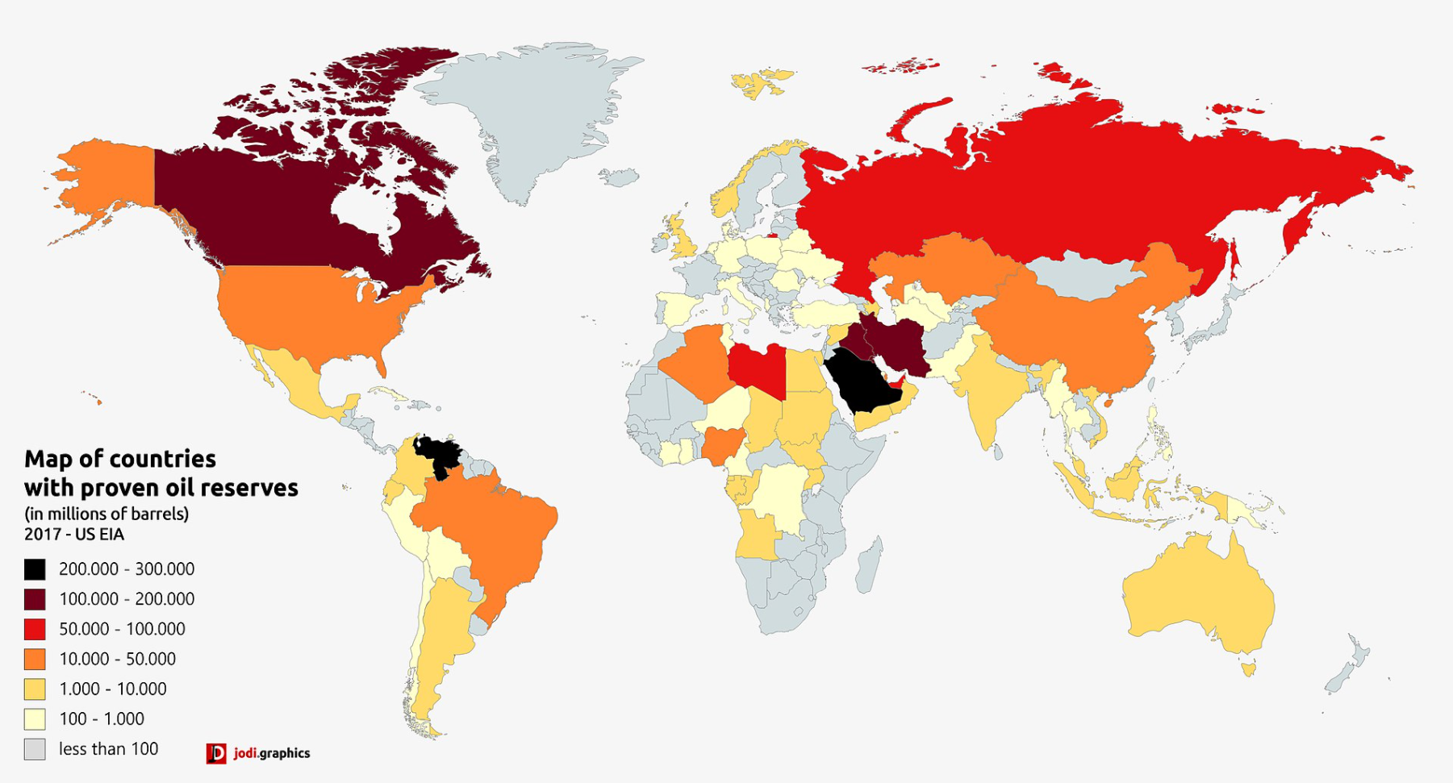

Global Oil Reserves

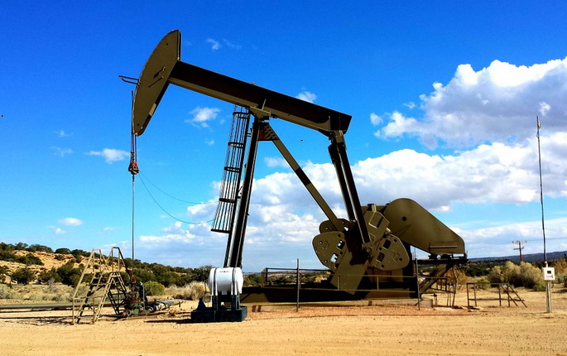

Petroleum Pump

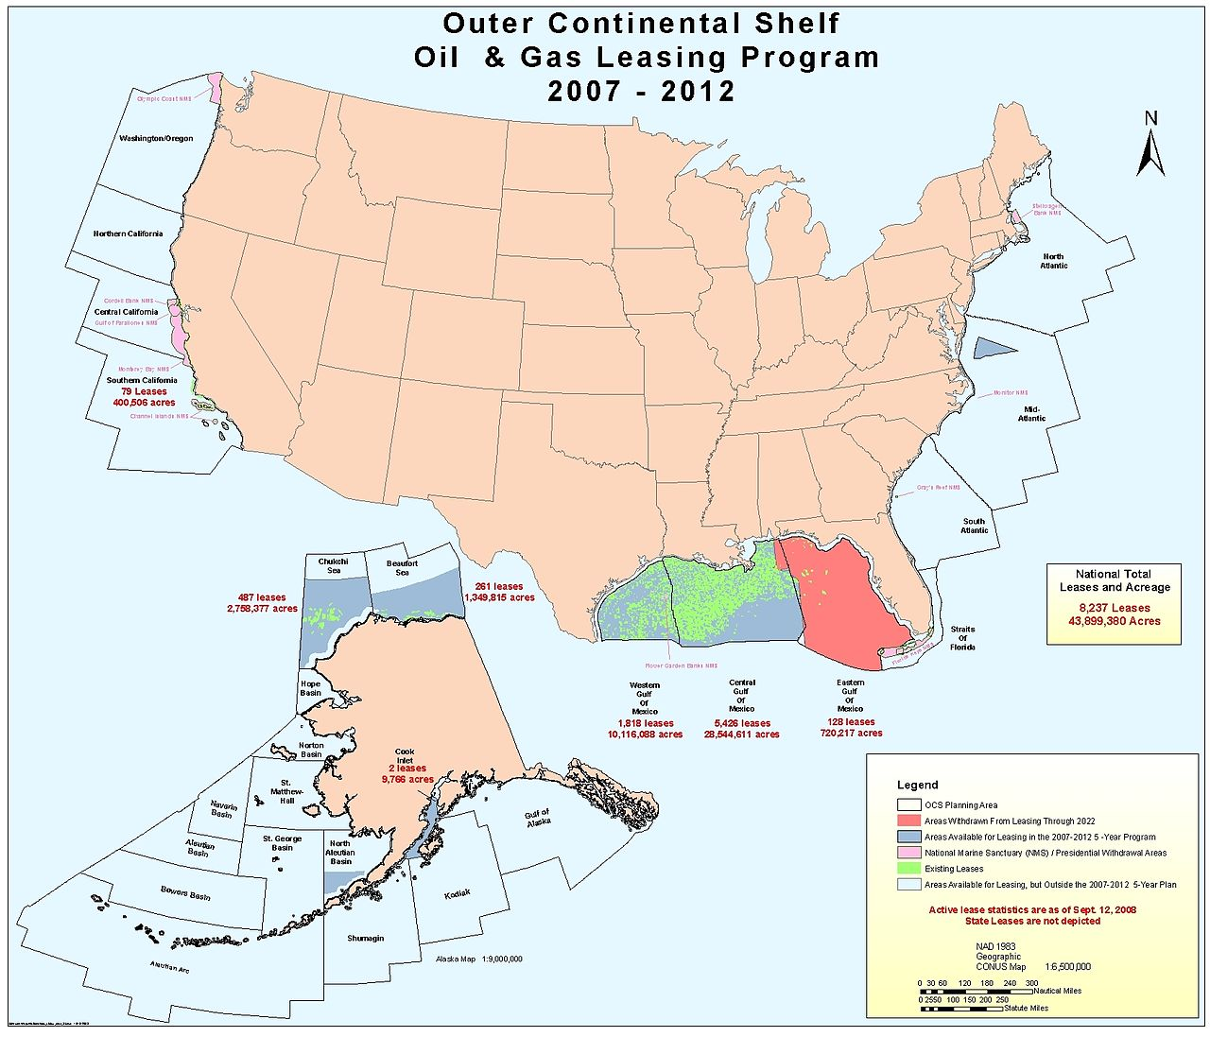

Offshore Oil Drilling in the US

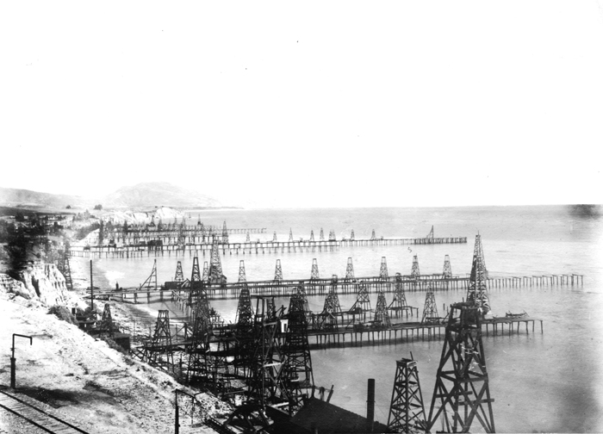

Oil wells in Summerland, CA 1902

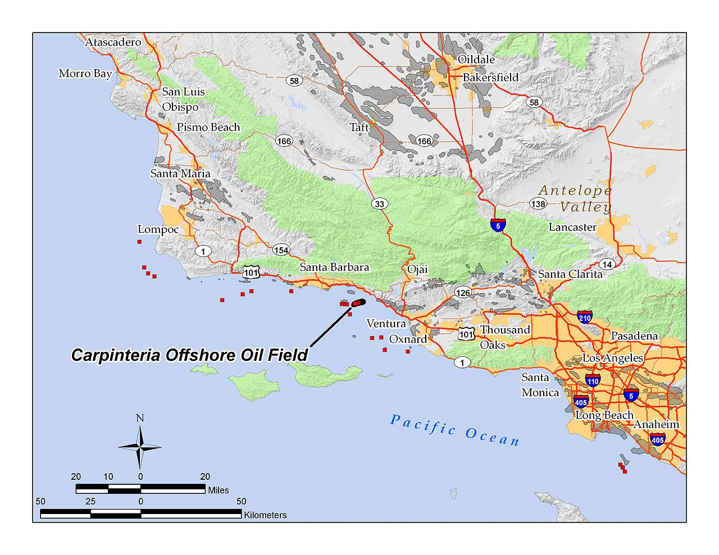

Off shore oil near Santa Barbara

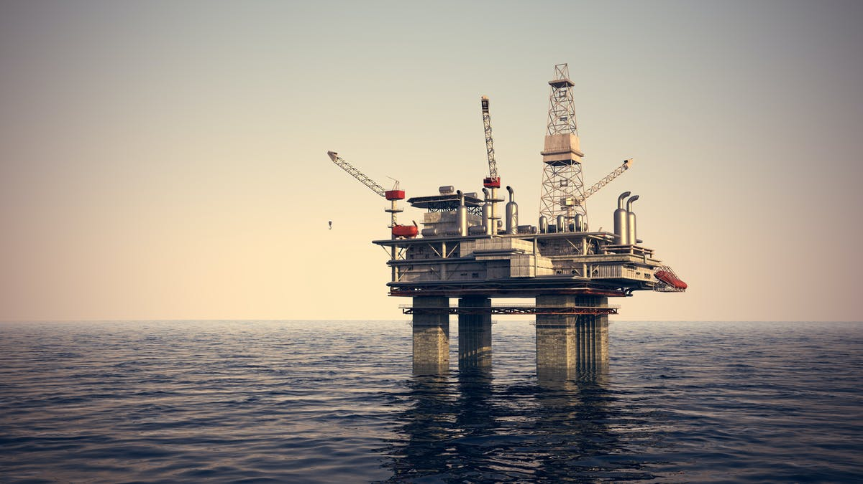

Off shore oil rig

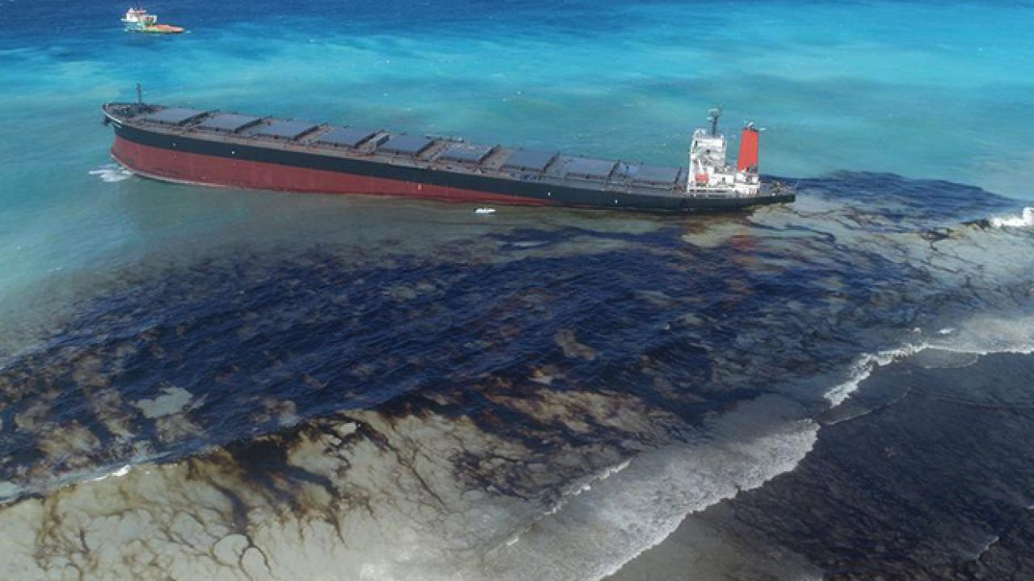

Mauritius Oil Spill

# Exit Survey

<https://forms.gle/5fERwe28Q4kBFdz38>